

MIT Art Design and Technology University
MIT School of Computing, Pune

Department of Computer Science and Engineering

Lab Manual

Subject – Machine Learning Lab

Class – F.Y. MSc (SEM-II)

Prof. Vijaya Patil

Prepared By: - Prof. Vijaya Patil
Required H/W and S/W: - 64 bit processor based machine and Visual Studio Code, Python

A.Y. 2025 – 2026 (SEM-II)
Lab Manual Index
Sl. No. | Title | Page No.
1 | - Installation and Configuration of machine learning environment with Anaconda on windows or Ubuntu (Jupyter notebook, spyder, vscode, pycharm)  - B.Installation, Configuration and checking the current Version of numpy, scipy, scikit, pandas and matplotlib using anaconda prompt and list their uses in machine learning. | 4-6
2 | Download any dataset from UCI or Data.org or from any other data repositories and perform the basic data pre-processing steps using python/R . | 7-9
3 | Write a program to implement k-Nearest Neighbour algorithm to classify the iris data set. Print both correct and wrong predictions. Python ML library classes can be used for this problem. | 10-12
4 | Implement a Support Vector Machine (SVM) classifier on the Iris dataset using Python. Train the model, evaluate its performance, and visualize the decision boundaries using appropriate plots. | 13-15
5 | Write a program to implement the naïve Bayesian classifier for a sample training data set stored as a .CSV file. Compute the accuracy of the classifier, considering few test data sets. | 16-18
6 | Write a program to demonstrate the working of the decision tree based ID3 algorithm. Use an appropriate data set for building the decision tree and apply this knowledge to classify a new sample. Developed model should be able to answer the given queries. | 19-21
7 | Implement a linear regression model on a suitable dataset using Python. Train the model, evaluate its performance, and visualize the regression results using appropriate plots. | 22-23
8 | Implement a logistic regression model on the Iris dataset using Python. Train the model, evaluate its performance, and visualize the classification results with appropriate plots. | 24-26
9 | Write a program to demonstrate the working of the K means algorithm. Use an appropriate data set and visualize the results. | 27-29
10 | Build an Artificial Neural Network by implementing the Backpropagation algorithm and test the same using appropriate data sets. | 30-32
11 | Case Study On ML Problem | 33-35

Prepared By – Prof. Vijaya Patil | Head - Dept. of CSE,

ASSIGNMENT 1: Installation and configuration of machine learning environment

Scenario: You joined a data science team at a leading e-commerce company. Your first task is to set up a machine learning environment to analyze customer purchase data and predict future buying patterns. This involves installing the required tools, libraries, and frameworks like Python, Jupyter Notebook, TensorFlow, or PyTorch, and ensuring all dependencies are configured correctly. A properly configured environment is essential for building, testing, and deploying machine learning models efficiently. Through this experiment, you'll simulate this foundational step in any real-world ML project.

Aim:

- Installation and Configuration of machine learning environment with Anaconda on windows or Ubuntu (Jupyter notebook, spyder, vscode, pycharm)

- Installation, Confguration and checking the current Version of numpy, scipy, scikit, pandas and matplot lib using anaconda prompt and list their uses in machine learning.

Objective

To install anaconda and configure it with Python

Tasks:

Installation Of Anaconda in Windows

- Visit the Anaconda downloads page

Go to the following link: Anaconda.com/downloads


- Select Windows

Select Windows where the three operating systems are listed.
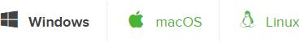

- Download

Download the most recent Python 3 release. At the time of writing, the most recent release was the Python 3.6 Version. Python 2.7 is legacy Python. For problem solvers, select the Python 3.6 version. If you are unsure if your computer is running a 64-bit or 32-bit version of Windows, select 64-bit as 64- bit Windows is most common.
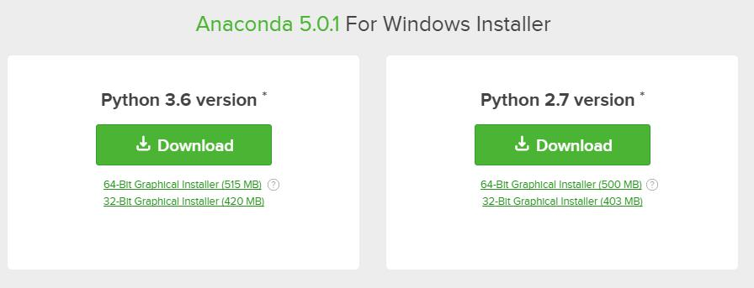

- Open and run the installer

Once the download completes, open and run the .exe installer
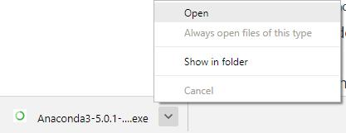

At the beginning of the install, you need to click Next to confirm the installation.
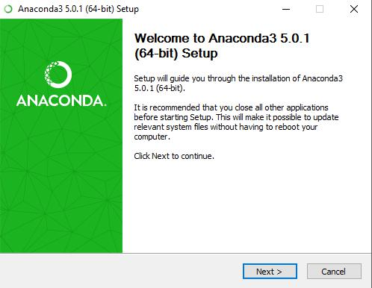

At the Advanced Installation Options screen, I recommend that you do not check "Add Anaconda to my PATH environment variable"

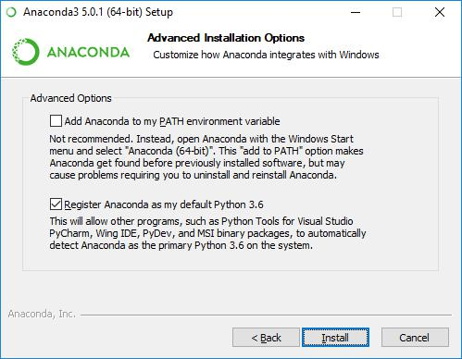

Installation Of Anaconda in Ubuntu

This section details the installation of the Anaconda distribution of Python on Linux, specifically Ubuntu 18.04, but the instructions should work for other Debian-based Linux distributions as well.

Ubuntu 18.04 comes pre-installed with Python (Version 3.6) and legacy Python (Version 2.7). You can confirm the legacy version of Python is installed by opening up a terminal.

- Visit the Anaconda downloads page

Go to the following link: Anaconda.com/downloads
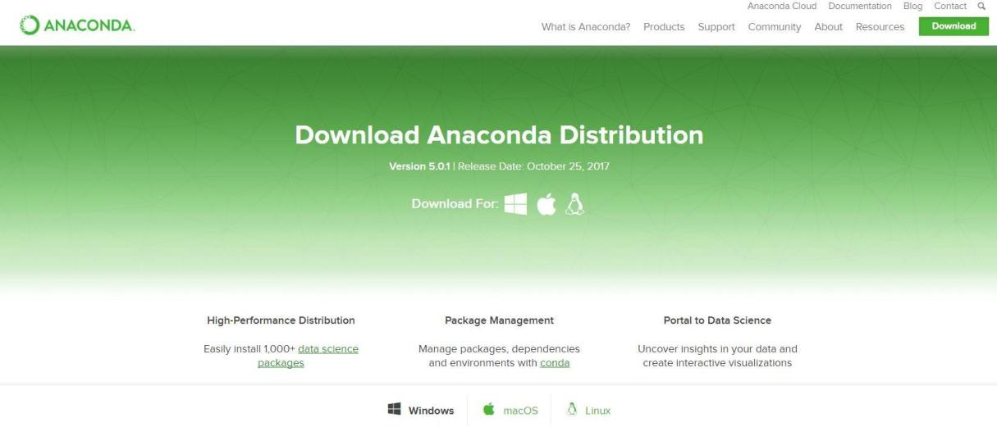

- Select Linux

On the downloads page, select the Linux operating system.
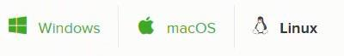

- Copy the bash (.sh file) installer link

In the Python 3.6 Version* box, right-click on the [64-Bit(x86) Installer] link. Select [copy link address].

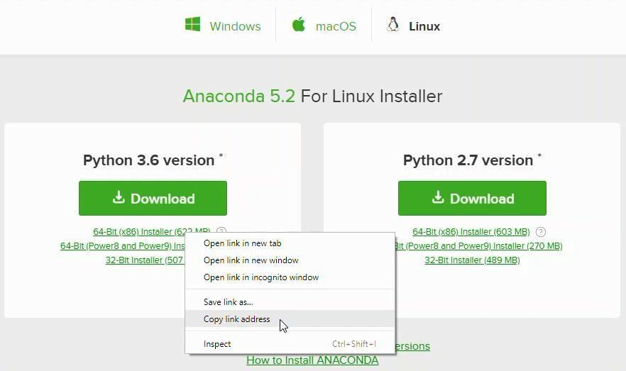

4. Use wget to download the bash installer
Now that the bash installer (.sh file) link is stored on the clipboard, use wget to download the installer script. In a terminal, cd into the home directory and make a new directory called tmp. cd into tmp and use wget to download the installer. Although the installer is a bash script, it is still quite large and the download will not be immediate (Note the link below includes <release>. the specific release depends on when you download the installer)
$ cd ~
$ mkdir tmp
$ cd tmp
$ https://repo.continuum.io/archive/Anaconda3<release>.sh
5. Run the bash script to install Anaconda3
With the bash installer script downloaded, run the .sh script
Anaconda3. Ensure you are in the directory where the installer script downloaded:
$ ls
Anaconda3-5.2.0-Linux-x86_64.sh Run
the installer script with bash.
$ bash Anaconda3-5.2.0-Linux-x86_64.sh
Accept the Licence Agreement and allow Anaconda to be added to your PATH. By adding Anaconda to your PATH, the Anaconda distribution of Python will be called when you type $ python in a terminal.
6. source the .bash-rc file to add Anaconda to your PATH
Now that Anaconda3 is installed and Anaconda3 is added to our PATH, source the .bashrc file to load the new PATH environment variable into the current terminal session. Note the .bashrc file is in the home directory.You can see it with $ ls -a.
$ cd ~
$ source .bashrc
Installation Of NumPy Command –
pip3 install numpy To check the
version
Import numpy as np
NUMPY/SCIPY:-
NumPy is a Python library, which stands for ‘Numerical Python’. It is the core library for scientific computing, which contains a powerful n-dimensional array object, provide tools for integrating C, C++ etc.
• NumPy array can also be used as an efficient multi-dimensional container for generic .data.
• The ndarray (NumPy Array) is a multidimensional array used to store values of same datatype. These arrays are indexed just like Sequences,starts with zero.
• The ndarrays are better than regular arrays in terms of faster computation and ease of manipulation.
• In different algorithms of Machine Learning like K-means Clustering, Random Forest etc. we have to store the values in an array. So, insteadof using regular array, ndarray helps us to manipulate and execute easily.

Installation of scikit
Command pip3 install -u scikit-learn
SCIKIT:-
The functionality that scikit-learn provides include:
• Regression, including Linear and Logistic Regression
• Classification, including K-Nearest Neighbors
• Clustering, including K-Means and K-Means++
• Model selection
• Preprocessing, including Min-Max Normalization.
Installation of Pandas
Command- pip3 install pandas
PANDAS:-
• Merging and Joining Data Sets.
• Reshaping & pivoting Data Sets.
• Inserting & deleting columns in Data Structure.
• Aligning data & dealing with missing data.
• Iterating over a Data set.
• Analyzing Time Series.
• Filtering Data around a condition.
• Arranging Data in an ascending & descending.
• Reading from flies with CSV, TXT, XLSX, other formats.
• Manipulating Data using integrated indexing for DataFrame objects.
• Generating Data range, date shifting, lagging, converting frequency, and other other Time Series functionality.
• Subsettting fancy indexing, & label based slicing Data Sets that are large in size.
Performing split apply combine on Data Sets using the group by engine. With Python Pandas, it is easier to clean & wrangle with your Data. features of Pandas make it a great choice for Data Science and Analysis.
MATPLOTLIB:-
• Matplotlib is a visualization library in Python for 2D plots of arrays. It consists of several plots like line, bar, scatter, histogram etc.
• Matplotlib is a multi-platform data visualization library built on NumPy arrays and designed to work with the broader SciPy stack.It can also be used with graphics toolkits like PyQt and wxPython.
One of the advantage of visualization is that it allows us visual access to huge amounts of data in easily digestible visuals.
Installation of Matplotlib Command-
pip3 install matplotlib
Conclusion
Thus we have successfully installed Anaconda on windows and Ubuntu; We also have described the libraries and the installation of the libraries.
!pip install torch==2.0.1+cpu torchvision==0.15.2+cpu -f https://download.pytorch.org/whl/cpu
!pip install intel-tensorflow
!pip install daal4py
!pip install scikit-learn-intelex
from sklearnex import patch_sklearn
patch_sklearn()
Rubric:
Criteria | Marks | Description
1. Installing Anaconda (Windows/Ubuntu) | 2 Marks | Successfully installs Anaconda on Windows or Ubuntu without errors. Verifies installation using conda --version.
2. Setting up Jupyter Notebook, Spyder, VS Code, and PyCharm | 2 Marks | Installs and configures Jupyter Notebook, Spyder, VS Code, and PyCharm via Anaconda. Launches each environment successfully.
3. Installing and Verifying Python Libraries | 2 Marks | Installs and verifies NumPy, SciPy, Scikit-learn, Pandas, and Matplotlib using Anaconda Prompt (conda list).
4. Checking Library Versions | 1 Mark | Uses Python (import package; package.__version__) or conda list to display installed library versions.
5. Listing Library Uses in Machine Learning | 2 Marks | Clearly explains how NumPy, SciPy, Scikit-learn, Pandas, and Matplotlib are used in machine learning.
6. Proper Documentation and Execution | 1 Mark | Provides a well-structured report or notebook documenting steps with commands, screenshots, or outputs.

ASSIGNMENT-2: Basic Data Pre-Processing (UCI Dataset)
Problem Statement
Before training any machine learning model, raw data must be cleaned and prepared.
Real-world datasets often contain:
- missing values
- duplicates
- inconsistent formats
- categorical variables
- outliers
Students must learn how to preprocess data correctly to make it suitable for analysis and modeling.

Scenario
A data analyst downloads a dataset from the UCI Machine Learning Repository.
The analyst must clean and prepare the data so that it becomes usable for future machine-learning projects.
The dataset contains information about plant species (Iris dataset).

Aim
To perform basic data preprocessing on a dataset using Python and Pandas.

Objectives
Students will be able to:
Import dataset from URL
Inspect dataset structure
Identify and handle missing values
Remove duplicate records
Encode categorical variables
Normalize numerical features
Save the cleaned dataset for future analysis

Dataset
Iris Dataset (UCI Repository)
Format: CSV (URL)

Tools Required
- Python
- Pandas / NumPy
- Scikit-learn
- Jupyter Notebook / Google Colab

TASKS (Answer ALL — 10 Questions)
Question 1 — Load Dataset
Load dataset from URL.
Print:
- first 10 rows
- number of rows and columns
- column names

Question 2 — Data Information
Display:
- data types of each column
- memory usage
Explain in 2–3 lines why data type matters.

Question 3 — Missing Values
Check:
- total missing values per column
- percentage of missing values
Explain if missing values exist.

Question 4 — Handle Missing Values
If missing values exist:
- numerical → fill with mean/median
- categorical → fill with mode
Explain chosen method.

Question 5 — Remove Duplicates
Check duplicates and remove them.
Print:
- number of duplicates removed

Question 6 — Descriptive Statistics
Display:
- mean
- median
- standard deviation
- min & max
Write brief interpretation.

Question 7 — Encode Categorical Variables
Convert target column to numeric using Label Encoding.
Explain why encoding is required.

Question 8 — Feature Scaling
Normalize numeric columns using:
- StandardScaler OR MinMaxScaler
Explain difference in 3–4 lines.

Question 9 — Correlation Analysis (Optional)
Print correlation matrix and identify:
- which features are strongly related.

Question 10 — Save Cleaned Dataset
Save processed file as:
cleaned_iris.csv
Explain why saving processed data is useful.

Conclusion
After completing this experiment, students will:
- understand importance of preprocessing
- clean datasets safely
- encode categorical variables
- scale numeric features
- prepare data for ML pipelines
Preprocessing ensures accurate, reliable machine-learning results.

Student Evaluation Rubric (10 Marks)
Criteria | Marks
Dataset loading & inspection | 2
Handling missing/duplicates | 2
Encoding categorical data | 2
Feature scaling | 2
Code clarity & explanation | 2

ASSIGNMENT – 3

k-Nearest Neighbour (k-NN) Classification

Problem Statement
Machine learning models require labelled data to classify new unseen records.
The k-Nearest Neighbour (k-NN) algorithm classifies data based on similarity with nearby examples.
In this assignment, students will implement k-NN to classify the Iris dataset and analyze model predictions.

Scenario
A data scientist is working on plant species classification.
Using petal and sepal measurements, the scientist needs to automatically determine:
- Iris-Setosa
- Iris-Versicolor
- Iris-Virginica
k-NN will be applied to classify unknown flower samples and evaluate prediction accuracy.
Aim
To write a Python program to implement the k-Nearest Neighbour algorithm and classify the Iris dataset using ML libraries.

Objectives
After completing this experiment, students will be able to:
Understand the working principle of k-NN
Load and preprocess datasets
Split dataset into training and testing sets
Train and test a k-NN classifier
Display correct and wrong predictions
Evaluate accuracy and model performance

Dataset
Iris Dataset – UCI Machine Learning Repository
Attributes:
- Sepal length
- Sepal width
- Petal length
- Petal width
- Species (class label)

Tools Required
- Python
- Google Colab / Jupyter Notebook / IDE
- Libraries:
  - pandas
  - numpy
  - scikit-learn
  - matplotlib (optional)

TASKS (Answer ALL — Q1 to Q10)
Q1. Load Dataset
Load Iris dataset and print first 10 records.

Q2. Display Dataset Details
Print:
- number of rows and columns
- column names
- target classes

Q3. Separate Features and Target
Create:
- X — feature matrix
- y — target labels
Explain in 2–3 lines.

Q4. Train–Test Split
Split dataset into training and testing sets (70:30).

Q5. Build k-NN Model
Create k-NN classifier (k = 3) and train it.

Q6. Predict Test Data
Predict class labels for test dataset.

Q7. Display Correct & Wrong Predictions
Print table:
| Actual | Predicted | Result |
Mark result as:
- Correct
- Wrong

Q8. Calculate Accuracy
Display model accuracy.

Q9. Discuss Misclassification
Identify wrongly predicted samples and explain possible reasons (2–3 points).

Q10. Conclusion
Write short conclusion about model performance and learning outcome.

Conclusion
By implementing k-NN, students will:
- understand distance-based classification
- evaluate model performance
- observe correct vs wrong predictions
- gain practical experience using ML libraries in Python
k-NN demonstrates how similarity plays an important role in decision-making.

Evaluation Rubric (10 Marks)
Criteria | Marks
Loading & understanding dataset | 2
Correct use of train-test split | 1
Implementation of k-NN | 2
Correct & wrong prediction display | 2
Accuracy calculation & explanation | 2
Presentation & comments | 1

ASSIGNMENT – 4
Support Vector Machine (SVM) Classification

Problem Statement
Support Vector Machine (SVM) is a supervised learning algorithm used for classification and regression.
It separates classes using an optimal decision boundary called a hyperplane.
In this assignment, students will implement SVM on a real dataset and visualize the classification boundary.

Scenario
A data analyst wants to classify objects into different categories based on their features.
Using SVM, the analyst needs to:
- train a classifier
- visualize how SVM separates classes
- evaluate performance
Students will observe how support vectors influence the decision boundary.

Aim
To write a Python program to demonstrate the working of the SVM algorithm, apply it on an appropriate dataset, and visualize the results.

Objectives
After completing this assignment, students will be able to:
Understand SVM concept and hyperplanes
Load and preprocess dataset
Train an SVM classifier using Python libraries
Visualize decision boundaries
Evaluate model accuracy
Interpret classification results

Dataset
Any suitable dataset containing at least two features and a class label, such as:
- Iris dataset (two selected features)
- Any linearly / non-linearly separable dataset
(Default recommended: Iris Dataset – UCI Repository)

Tools Required
- Python
- Google Colab / Jupyter Notebook
- Libraries:
  - pandas
  - numpy
  - scikit-learn
  - matplotlib / seaborn

TASKS (Answer ALL — Q1 to Q10)
Q1. Load Dataset
Load dataset and display first 10 rows.

Q2. Show Dataset Information
Print:
- number of rows & columns
- data types
- unique class labels

Q3. Select Features
Select two numeric features for visualization (example: petal length & petal width).
Explain in 1–2 lines.

Q4. Split Dataset
Split dataset into:
- Training set
- Testing set (70:30)

Q5. Build SVM Model
Create SVM classifier using:
kernel = 'linear' (or try ‘rbf’)
Train the model on training data.

Q6. Predict Test Data
Predict class labels for test samples.

Q7. Compare Predictions
Print table:
| Actual | Predicted | Result |
Mark Correct / Wrong.

Q8. Visualize Decision Boundary
Plot:
- data points
- SVM decision boundary
- support vectors (if possible)

Q9. Evaluate Model
Print:
- accuracy score
- confusion matrix
Interpret results briefly.

Q10. Conclusion
Write 4–5 lines about:
- SVM working
- accuracy
- advantages / limitations

Conclusion
Students will learn:
- how SVM separates classes using hyperplanes
- the effect of support vectors
- how visualization helps understand ML models
- performance evaluation using metrics
SVM is powerful for classification tasks with both linear and non-linear boundaries.

Evaluation Rubric (10 Marks)
Criteria | Marks
Dataset loading & exploration | 2
Correct SVM implementation | 2
Train–test split & prediction | 2
Visualization of results | 2
Explanation & clarity | 2

ASSIGNMENT – 5
Naive Bayes Classifier

Problem Statement
Naive Bayes is a probabilistic classifier based on Bayes’ theorem.
It is widely used in spam filtering, text classification, and medical diagnosis.
In this assignment, students will:
- load a training dataset from a CSV file
- train a Naive Bayes classifier
- test with sample inputs
- compute classification accuracy

Scenario
A data analyst needs to classify records automatically based on previous labelled data.
The training dataset is stored in CSV format.
The analyst will use Naive Bayes to predict the class for new test records and evaluate performance.

Aim
To write a Python program to implement Naive Bayes classifier using a CSV dataset and compute accuracy using test samples.

Objectives
After completing this assignment, students will be able to:
understand Bayes theorem and Naive independence assumption
load dataset from CSV file
train Naive Bayes classifier
predict class labels for test records
evaluate classifier accuracy
interpret classification results

Dataset
Any labelled CSV dataset can be used. Examples:
- Iris dataset (CSV)
- Weather dataset
- Student result dataset
Format should include:
- input features
- class label column

Tools Required
- Python
- Google Colab / Jupyter Notebook
- Libraries:
  - pandas
  - numpy
  - scikit-learn

TASKS (Answer ALL — Q1 to Q10)
Q1. Load CSV Dataset
Load dataset from CSV and display first 10 rows.

Q2. Dataset Information
Print:
- number of rows & columns
- column names
- class distribution

Q3. Separate Features & Target
Divide dataset into:
- X → input features
- y → class label
Explain in 1–2 lines.

Q4. Train–Test Split
Split dataset into training and testing datasets (70:30 or 80:20).

Q5. Build Naive Bayes Classifier
Use:
GaussianNB() or MultinomialNB()
Train using training data.

Q6. Predict on Test Data
Predict class outputs for test records.

Q7. Compare Predictions
Display a table:
| Actual | Predicted | Result |
Mark:
- Correct
- Wrong

Q8. Compute Accuracy
Print:
- accuracy score
Explain briefly.

Q9. Evaluate Performance
(Optional but recommended)
Print:
- confusion matrix
- classification report

Q10. Conclusion
Write a brief summary:
- working of Naive Bayes
- accuracy achieved
- where it can be applied

Conclusion
After performing this experiment, students will:
- understand probabilistic classification
- work with CSV datasets
- evaluate and interpret classifier results
Naive Bayes is simple, fast, and effective for many classification problems.

Evaluation Rubric (10 Marks)
Criteria | Marks
Loading CSV & understanding dataset | 2
Splitting & preprocessing data | 2
Correct Naive Bayes implementation | 2
Accuracy calculation | 2
Interpretation & presentation | 2

ASSIGNMENT – 6
Decision Tree (ID3 Algorithm)

Problem Statement
Decision Trees are popular classification methods that split data based on feature values.
The ID3 algorithm builds a decision tree using:
- Entropy
- Information Gain
In this assignment, students will build a decision tree, visualize it, classify new samples, and answer queries using the trained model.

Scenario
A data analyst wants to automatically classify records based on attributes such as:
- weather
- temperature
- humidity
- wind
Using historical labelled data, the analyst must:
- build a decision tree using ID3
- predict the class for new unseen samples
- answer decision-making queries from the model

Aim
To write a Python program to demonstrate the working of the Decision Tree (ID3) algorithm, classify new samples, and interpret results.

Objectives
After completing this assignment, students will be able to:
understand entropy and information gain
construct decision trees using ID3
visualize the decision tree
classify new samples
interpret decisions explained by the tree
answer queries based on the model

Dataset
Any labelled dataset may be used, such as:
- Weather dataset
- Play Tennis dataset
- Student Performance dataset
- Iris dataset
Dataset should contain:
- multiple feature attributes
- one target class column
(Default recommended: Play Tennis dataset.)

Tools Required
- Python
- Google Colab / Jupyter Notebook
- Libraries:
  - pandas
  - numpy
  - scikit-learn
  - graphviz / matplotlib (for visualization)

TASKS (Answer ALL — Q1 to Q10)
Q1. Load Dataset
Load dataset (CSV / built-in) and display first 10 rows.

Q2. Dataset Summary
Print:
- shape
- columns
- class distribution

Q3. Data Pre-Processing
Handle:
- missing values (if any)
- categorical encoding
Explain briefly.

Q4. Separate Features & Target
Prepare:
- X — feature matrix
- y — class label

Q5. Build Decision Tree (ID3 Algorithm)
Use:
criterion = "entropy"
Train the decision tree model.

Q6. Visualize the Tree
Draw tree using:
- plot_tree() or graphviz
Label nodes and classes.

Q7. Predict on Test Data
Predict class labels for test dataset.
Create table:
| Actual | Predicted | Result |

Q8. Classify New Sample
Create a new record (manually) and classify it using the trained model.
Example:
Outlook = Sunny
Temp = Mild
Humidity = High
Wind = Weak
Observe predicted result.

Q9. Answer Queries
Use the model to answer queries like:
- Will the person play?
- Which feature affected the decision the most?
- What happens if humidity changes?
Explain briefly.

Q10. Evaluate Performance
Print:
- accuracy
- confusion matrix
Explain results.

Conclusion
After completing this experiment, students will:
- understand ID3 algorithm
- construct interpretable decision trees
- classify unseen samples
- explain reasoning behind predictions
Decision trees provide transparent, rule-based decision models.

Evaluation Rubric (10 Marks)
Criteria | Marks
Dataset loading & preparation | 2
Correct decision tree building (ID3) | 2
Visualization of tree | 2
Classification of new sample | 2
Analysis & explanation | 2

ASSIGNMENT – 7
Linear Regression

Problem Statement
Linear Regression is a supervised learning algorithm used to model the relationship between:
- one or more independent variables (features)
- one dependent variable (target)
It fits a straight line (best-fit line) to predict future values.
In this assignment, students will:
- build a linear regression model
- train it using an appropriate dataset
- visualize the regression line
- evaluate model performance

Scenario
A data analyst wants to predict values such as:
- house prices
- marks vs study hours
- salary vs experience
- sales vs advertising budget
Using historical data, Linear Regression will be applied to estimate future values.

Aim
To implement Linear Regression using Python and visualize the regression line on the dataset.

Objectives
After completing this assignment, students will be able to:
understand concept of regression and best-fit line
load dataset and prepare features/target
train linear regression model
predict new output values
visualize regression line
evaluate model performance

Dataset
Any simple numeric dataset such as:
- Salary vs Years of Experience
- Study Hours vs Marks
- House Prices dataset
- Built-in datasets (sklearn)
(Default recommended: Salary vs Experience dataset)
Dataset should include:
- at least one independent feature
- one dependent variable (continuous)

Tools Required
- Python
- Google Colab / Jupyter Notebook
- Libraries:
  - pandas
  - numpy
  - scikit-learn
  - matplotlib / seaborn

TASKS (Answer ALL — Q1 to Q10)
Q1. Load Dataset
Load dataset and display first 10 rows.

Q2. Dataset Summary
Print:
- shape
- columns
- description / statistics

Q3. Separate Features & Target
Prepare:
- X → independent variable(s)
- y → dependent variable
Explain briefly.

Q4. Visualize Relationship
Draw a scatter plot to understand relationship.

Q5. Train Linear Regression Model
Fit the model to training data.

Q6. Display Regression Line
Plot:
- scatter points
- regression line

Q7. Predict on Test Data
Predict values for test dataset.

Q8. Predict for New Input
Manually give new value and display predicted output.
Example:
Experience = 5 years

Q9. Evaluate Model
Compute:
- Mean Squared Error (MSE)
- R² Score
Interpret briefly.

Q10. Conclusion
Write conclusion about:
- model performance
- usefulness of linear regression

Conclusion
After completing this assignment, students will:
- understand basic regression models
- visualize best-fit line
- make predictions on unseen data
- evaluate regression performance
Linear Regression is a fundamental technique used widely in data science.

Evaluation Rubric (10 Marks)
Criteria | Marks
Dataset loading & understanding | 2
Correct regression implementation | 2
Visualization of regression line | 2
Prediction and evaluation | 2
Explanation & presentation | 2

ASSIGNMENT – 8
Logistic Regression

Problem Statement
Logistic Regression is a supervised learning technique used for classification.
It predicts the probability that an instance belongs to a particular class using the sigmoid function.
In this assignment, students will:
- train a Logistic Regression model
- classify data into categories
- visualize the decision boundary
- evaluate performance

Scenario
A data analyst wants to make decisions such as:
- pass / fail
- spam / not spam
- disease / no disease
- admit / not admit
Using labelled data, Logistic Regression will be used to classify future cases.

Aim
To implement Logistic Regression using Python, classify a dataset, and visualize the results.

Objectives
After completing this assignment, students will be able to:
understand logistic vs linear regression
prepare a dataset for classification
train a Logistic Regression model
predict class labels for new samples
visualize classification regions
evaluate model accuracy

Dataset
Any binary or multi-class dataset such as:
- Iris (2-class subset)
- Breast Cancer dataset
- Student admission dataset
- Custom CSV dataset
(Default recommended: Iris dataset (two features))

Tools Required
- Python
- Google Colab / Jupyter Notebook
- Libraries:
  - pandas
  - numpy
  - scikit-learn
  - matplotlib / seaborn

TASKS (Answer ALL — Q1–Q10)
Q1. Load Dataset
Load dataset and display first 10 rows.

Q2. Dataset Information
Print:
- rows, columns
- feature names
- number of classes

Q3. Select Features & Target
Choose two numerical features and one target class.
Explain choice in 1–2 lines.

Q4. Train–Test Split
Split dataset into:
- training set
- test set
(70:30 or 80:20)

Q5. Build Logistic Regression Model
Train model using training data.

Q6. Predict on Test Data
Predict class labels.
Create table:
| Actual | Predicted | Result |

Q7. Compute Accuracy
Print:
- Accuracy
- Classification report
Interpret briefly.

Q8. Visualize Decision Boundary
Plot:
- data points
- decision boundary / regions
Explain what the visualization shows.

Q9. Predict New Sample
Give a manual input and predict class.
Example:
Feature1 = 4.8
Feature2 = 1.6

Q10. Conclusion
Write short conclusion:
- how Logistic Regression works
- accuracy observed
- where it is useful

Conclusion
After completing this experiment, students will:
- understand probability-based classification
- visualize decision boundaries
- evaluate model quality
- classify unseen samples
Logistic Regression is simple yet powerful for many classification problems.

Evaluation Rubric (10 Marks)
Criteria | Marks
Dataset loading & understanding | 2
Correct model implementation | 2
Predictions & accuracy | 2
Visualization | 2
Explanation & presentation | 2

ASSIGNMENT – 9
K-Means Clustering

Problem Statement
K-Means is an unsupervised learning algorithm used to group data into clusters based on similarity.
In this assignment, students will:
- apply K-Means clustering on a dataset
- choose an appropriate value of K
- visualize the clusters
- interpret the results

Scenario
A data analyst wants to group similar records, for example:
- grouping students based on marks
- grouping customers based on shopping behavior
- grouping images based on color features
- grouping cities based on weather patterns
Since there are no class labels, K-Means will automatically discover natural groups.

Aim
To write a Python program to demonstrate the working of the K-Means algorithm and visualize the resulting clusters.

Objectives
After completing this assignment, students will be able to:
understand clustering and distance-based grouping
apply K-Means to unlabeled datasets
choose K using the Elbow Method
visualize clusters and centroids
interpret clustering results

Dataset
Any unlabeled dataset can be used, such as:
- Iris dataset (only features, remove labels)
- Students marks dataset
- Customer spending dataset
(Default recommended: Iris features)
Dataset should have:
- 2 or more numeric features

Tools Required
- Python
- Google Colab / Jupyter Notebook
- Libraries:
  - pandas
  - numpy
  - scikit-learn
  - matplotlib / seaborn

TASKS (Answer ALL — Q1 to Q10)
Q1. Load Dataset
Load dataset and display first 10 rows.

Q2. Dataset Overview
Print:
- shape
- features
- summary statistics

Q3. Select Features
Remove labels (if present).
Explain why clustering does not use class labels.

Q4. Visualize Raw Data
Create a scatter plot for two features.

Q5. Apply K-Means Algorithm
Choose K (number of clusters) and train model.

Q6. Assign Cluster Labels
Add cluster numbers to dataset and display first few rows.

Q7. Elbow Method (Optional but recommended)
Plot:
K vs Sum of Squared Errors (SSE)
Identify best K.

Q8. Visualize Clusters
Plot:
- clusters with different colors
- centroids highlighted
Explain pattern seen.

Q9. Interpret Results
Answer questions such as:
- how many clusters formed?
- what does each cluster represent?

Q10. Conclusion
Explain briefly:
- how K-Means works
- usefulness of clustering
- observations from visualization

Conclusion
After completing this assignment, students will:
- understand unsupervised learning
- group similar data without labels
- interpret clusters visually
- apply clustering in real-world problems

Evaluation Rubric (10 Marks)
Criteria | Marks
Dataset preparation & understanding | 2
Correct K-Means implementation | 2
Cluster assignment | 2
Visualization & interpretation | 2
Explanation & presentation | 2

ASSIGNMENT – 10
Artificial Neural Network (Backpropagation)

Problem Statement
Artificial Neural Networks (ANNs) are powerful machine-learning models inspired by the human brain.
They learn from data by adjusting weights using the Backpropagation algorithm.
In this assignment, students will:
- build an ANN model
- train it using backpropagation
- test on appropriate dataset
- evaluate and interpret results

Scenario
A data analyst wants to solve problems such as:
- predicting handwritten digits
- disease prediction
- loan approval
- student performance prediction
Using labelled datasets, ANN with Backpropagation will be applied to classify or predict outcomes.

Aim
To build an Artificial Neural Network using Backpropagation and test the trained network on suitable datasets.

Objectives
After completing this experiment, students will be able to:
✔ understand structure of ANN (input-hidden-output)
✔ implement backpropagation learning
✔ train network using dataset
✔ evaluate accuracy and loss
✔ interpret model performance

Dataset
Any supervised dataset may be used, such as:
- Iris dataset
- MNIST digits (subset)
- Breast cancer dataset
- Student marks dataset
(Default recommended: Breast Cancer Dataset)
Dataset should contain:
- input features
- one target label column

Tools Required
- Python
- Google Colab / Jupyter Notebook
Libraries:
- numpy
- pandas
- scikit-learn
- tensorflow / keras (or PyTorch)

TASKS (Answer ALL — Q1 to Q10)
Q1. Load Dataset
Load dataset and show first 10 rows.

Q2. Dataset Summary
Display:
- rows, columns
- feature names
- class distribution

Q3. Data Pre-Processing
Perform:
- handling missing values
- normalization / scaling
- train–test split
Explain briefly.

Q4. Build Neural Network Architecture
Create ANN with:
- Input layer
- At least one Hidden layer
- Output layer
Describe number of neurons used.

Q5. Initialize Parameters
Choose:
- activation functions
- optimizer
- learning rate
- loss function
Explain in short.

Q6. Train Network (Backpropagation)
Train the network for several epochs
Observe loss decreasing.

Q7. Evaluate Model
Calculate:
- accuracy
- loss
Explain what values indicate.

Q8. Predict Using Trained Model
Predict output for some test samples and compare.
Create table:
| Actual | Predicted | Result |

Q9. Visualize Training
Plot:
- Loss vs Epochs
- Accuracy vs Epochs (if classification)
Explain trend.

Q10. Conclusion
Write short conclusions:
- how ANN learned
- how well it performed
- where such models are useful

Conclusion
After completing this experiment students will:
- understand ANN concepts
- appreciate role of backpropagation
- evaluate deep learning models
- apply ANN in real-world problems

Evaluation Rubric (10 Marks)
Criteria | Marks
Dataset preparation | 2
Correct ANN architecture | 2
Backpropagation training | 2
Evaluation & visualization | 2
Explanation & presentation | 2

ASSIGNMENT-10
CASE STUDY
Deep Learning & Image Processing for Real-World Image Classification

Problem Definition
Hospitals receive thousands of medical images (X-rays, MRI scans, CT images).
Manual diagnosis is:
- time-consuming
- requires expert radiologists
- prone to human error
The goal:
Automatically classify chest X-ray images as “Normal” or “Pneumonia.”
Deep learning + image processing can help:
- reduce workload of doctors
- detect diseases faster
- support decision making

Dataset
Dataset used:
Chest X-Ray Dataset (Kaggle / NIH)
Contains:
Type | Count
Normal | 5,000+
Pneumonia | 6,000+
Images have variations:
- different brightness
- noise
- different sizes
- different quality cameras

Image Processing (Pre-processing Steps)
Before training, images are cleaned and standardized.
Resize images (e.g., 224×224)
Convert to grayscale or normalize pixels
Remove noise and blur using filters
Data augmentation to avoid overfitting
Examples:
- rotation
- flipping
- zoom
- brightness adjustments
Why?
Improves generalization and helps the model learn robust patterns.

Deep Learning Model
We use Convolutional Neural Networks (CNN) because they work best for images.
Typical architecture:
Convolution layers
ReLU activation
MaxPooling layer
Fully connected layers
Sigmoid/Softmax output
Alternatively, transfer learning can be used:
- VGG16
- ResNet50
- MobileNet
Transfer learning is preferred because:
needs less data
trains faster
gives higher accuracy

Training & Evaluation
Train–Test Split
- 80% training
- 20% testing
Metrics Used
Accuracy
Precision
Recall
F1-Score
Because in medical cases:
Missing disease (false negative) is more dangerous than false positive.

Results (Example)
Model | Accuracy
Simple CNN | 86%
CNN + Augmentation | 90%
Transfer Learning (ResNet50) | 95–97%
Model successfully identifies image patterns like:
- cloudy lungs (pneumonia)
- clear lungs (normal)

Challenges Faced
Unbalanced data (more pneumonia than normal)
Similar looking images
Noise and artifacts in scans
Risk of overfitting
Handled using:
- augmentation
- dropout regularization
- transfer learning
- careful evaluation

Applications of This Approach
Medical imaging (X-ray, MRI, CT)
Face recognition
Traffic sign recognition
Satellite image analysis
Industrial defect detection
Agriculture (leaf disease detection)

Conclusion
Deep learning combined with image processing:
- automates image analysis
- improves accuracy and speed
- supports professionals in decision making
However, models must be:
- validated carefully
- ethically used
- supported by domain experts (not replace doctors!)

VIVA QUESTIONS
- Which library is used for numerical computations in Python? → NumPy
- What function in Pandas is used to read CSV files? → read_csv
- Which Matplotlib function is used to plot a line graph? → plot()
- What function in Pandas returns the shape of a DataFrame? → shape
- Which library is commonly used for statistical data visualization? → Seaborn
- What type of probability distribution follows a bell curve? → Normal
- Which test is used to compare two means? → t-test
- What is the measure of dispersion in a dataset? → Variance
- Which statistical metric is used to measure data spread? → Standard Deviation
- What does the R-squared value indicate in regression? → Goodness of Fit
- What is the rank of a square matrix with all zero rows? → Zero
- What is the determinant of an identity matrix? → One
- Which operation is used to transform a vector? → Matrix Multiplication
- What do you call a matrix with all elements zero except the diagonal? → Diagonal Matrix
- What is the inverse of a non-invertible matrix? → Not Defined
- What is the derivative of a constant function? → Zero
- Which function is used to optimize loss in ML? → Gradient Descent
- What is the partial derivative of x² with respect to x? → 2x
- What is the gradient of a function? → Vector of Derivatives
- What is the term for a point where a function’s derivative is zero? → Critical Point
- Which package manager is used in Anaconda? → Conda
- What is the default IDE in Anaconda? → Jupyter Notebook
- Which command lists installed packages in Anaconda? → conda list
- What is the primary use of VS Code in ML? → Code Editing
- Which library is used for deep learning in Python? → TensorFlow
- Which Pandas function shows the first five rows? → head()
- Which metric measures data central tendency? → Mean
- Which chart is best for visualizing categorical data? → Bar Chart
- What type of plot is used for correlation analysis? → Heatmap
- Which function finds missing values in a dataset? → isnull()
- What is the target variable in regression? → Continuous
- What is the formula for linear regression? → y = mx + c
- Which regression model minimizes squared error? → OLS (Ordinary Least Squares)
- What type of regression prevents overfitting? → Ridge Regression
- What is the loss function used in linear regression? → Mean Squared Error (MSE)
- Which ML algorithm is used for spam detection? → Naïve Bayes
- What is the decision boundary in SVM? → Hyperplane
- What is the full form of KNN? → K-Nearest Neighbors
- Which metric is used for classification accuracy? → F1-Score
- What does the ROC curve represent? → Model Performance
- What is the number of clusters in K-Means called? → K
- What type of clustering does DBSCAN perform? → Density-Based
- Which algorithm uses hierarchical clustering? → Agglomerative Clustering
- What is the primary metric used in clustering evaluation? → Silhouette Score
- What does PCA stand for? → Principal Component Analysis
- Which technique reduces data dimensions? → PCA
- What does t-SNE stand for? → t-Distributed Stochastic Neighbor Embedding
- What is the main purpose of dimensionality reduction? → Reduce Complexity
- Which technique is used before PCA for better results? → Feature Scaling
- What is the key hyperparameter in PCA? → Number of Components
- What is the most commonly used deployment framework? → Flask
- Which cloud platform offers ML model deployment? → Google Cloud (GCP)
- What is a trained model saved as in TensorFlow? → .h5 or .pb
- What is the purpose of API in ML deployment? → Model Serving
- Which library is used to serialize ML models? → Pickle

